***NOTE: Do NOT omit any required telephone alert calls or radio calls, even if using MatterMost***

______ 1. Verify correct checklist. Calendar Date/Time: _______________________Z

______ 2. Obtain the flying schedule for the next day from MOC.

______ A. Locate **305/514 AMW local training** (ex: TEAM, BEEF callsign) mission. → **Go to Step 3**

______ B. Locate **305/514 AMW operational** (ex: RCH callsign/TACC) mission → **Go to Step 4**

______ C. Locate each flying mission from all other units → **Go to Step 5**

______ 3. (0900Z/1800Z) For all **305/514 AMW local training** missions:

______ A. Open GDSS Mission Dashboard, customize your columns, and copy & paste one flight at a time into Microsoft Excel



Also save Crew Papers as a PDF (right click and select Publish Package if needed)

______ B. Open Microsoft Excel, select blank workbook

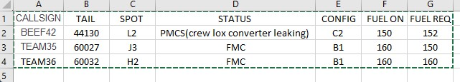

______ C. Open Mattermost

______ (1). Go to 305 AMW Team / Command Post Channel (Local Flights Only)

______ (2). Type [date] [morning/evening] [locals] (ex: 23 OCT EVENING LOCALS), press ENTER

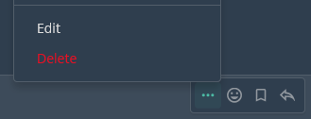______ (3). Copy & paste the table from Microsoft Excel for local missions, press ENTER

(click “…” and “edit” if the chart does not paste correctly, or the spot check changes)

______ (4). Click  and attach ew papers, press ENTER

______ (5). Tag the acft commander by typing “@[lastname][squadron]”, press ENTER

***NOTE: If you can not find an AC in MM, type “ACs not found in MM” @john.cockburn***

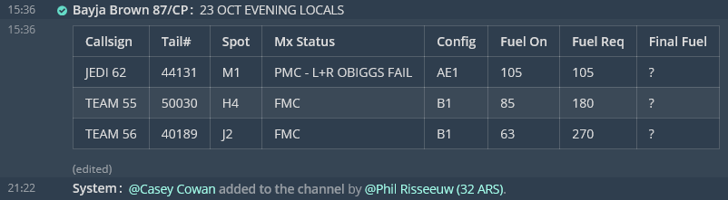

______ (6). Monitor channel for follow on remarks from aircrew (ex: final fuel)

______ 4. For all **305/514 AMW operational** missions

______ A. Note scheduled Legal For Alert time: Z & Acft Commander

______ (1). Download published crew papers and save as [CALLSIGN] [Depart ICAO]- [Arrive ICAO]” (ex: RCH123 KWRI-ETAR)

______ B. Open MatterMost

______ (1). Go to  618 AOC-MOD Team

______ (2). Check to see if a channel has already been created. 618 AOC manages some missions from start to finish. 87 CP will manage all missions starting out of KWRI

______ (3). Create public channel by clicking (+) on 

______­ (4). Name channel [CALLSIGN] - [TAIL#] - [MISSION#] – CP SPT ONLY

(ex: RCH147 - 70028 - PJZF5141C269)

Tag @first.last; @first.last (continue list of controllers & AC)

______ (5). Type “KWRI CP is only providing support on MatterMost for KWRI departure leg only. Enroute support via MM may be provided by local CP or AMCC (location dependent). 618 AOC will support MM for crew paper delivery at austere locations.” press ENTER

______ (6). Fill in Callsign:_ Tail#:_Spot:_Status:_Config:_Fuel on board:_Req Fuel:_

Click  and attach crew papers. Then tag the AC by typing “@[lastname]”

Press ENTER at **LFA time**

Example: CALLSIGN: RCH286 TAIL#: 44134 SPOT: L2 STATUS: PMCB (RIGHT OBIGGS FAIL) CONFIG: C3 FUEL ON BOARD: 28 REQ FUEL: 140 RCH286 KWRI-EGUN.pdf @Noah Clark @David Yi

***NOTE: If you can not find an acft cmdr in MatterMost. Type “ACs not found in MM” @john.cockburn***

______ (7). Monitor channel for follow on remarks from aircrew (ex: final fuel)

______ 5. For Transient or other mission in GDSS.

______ A. Note scheduled Legal For Alert time: _______Z & Acft Commander ________________

______ (1). If crew papers are requested by aircrew, you can offer two methods:

______ a. Print: Crews must come to the 87 ABW/CP vestibule, utilizing COVID19 precautionary measures (social distancing and face coverings)

______ b. Email: Can only be sent to their us.af.mil addresses and must be encrypted CUI